How to Read a Label
Use the label below to find the following information:

1. Circle the EPA Registration Number (EPA Reg. No.).

2. What should you do after handling bait stations?

3. Can this product be used outdoors?

4. How often should you replace the baits?

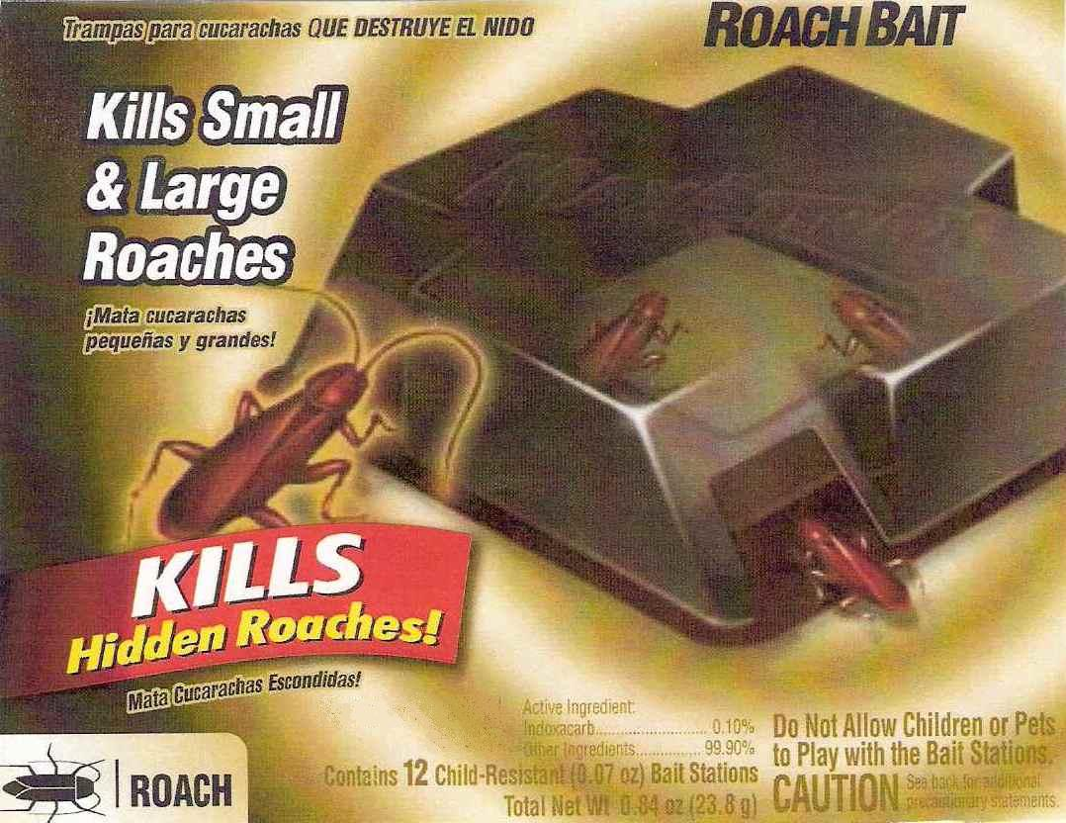
For indoor household
use only.

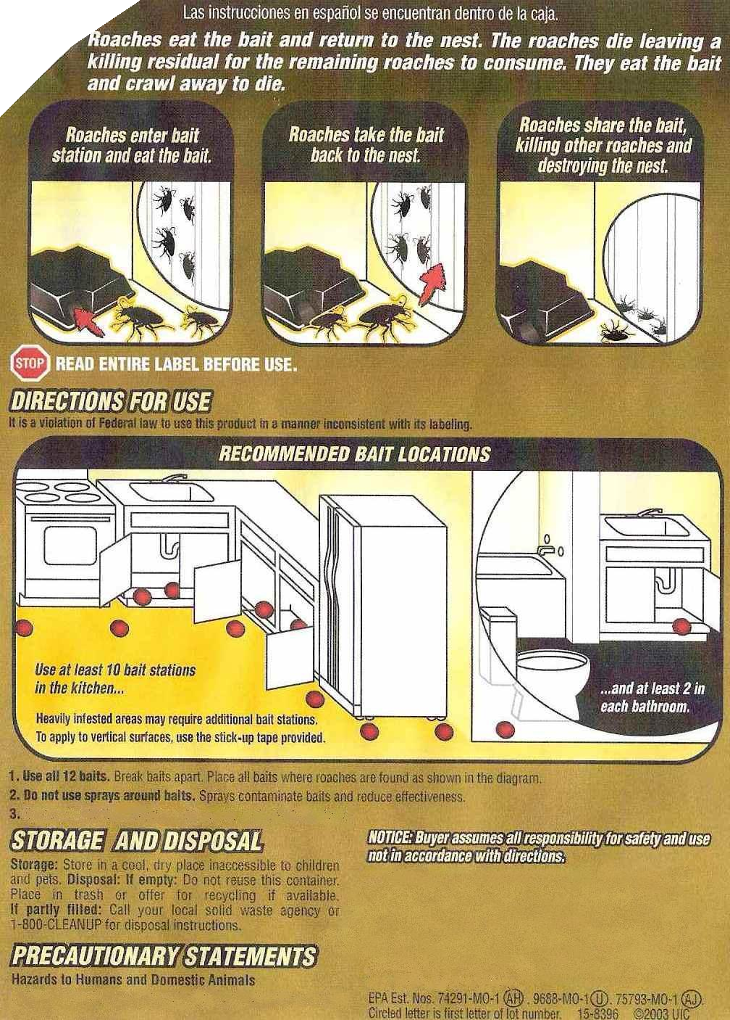
Replace all baits every 3 months or sooner if roaches return.
CAUTION. Wash hands thoroughly with soap and water
after handling bait stations.
EPA Reg. No. 9688-193-8845

